**Indian Sign Language Prediction System**

**Using Machine Learning**

**Master of Computer Science**

**By**

**PRACHITI CHANDRAKANT ADAM**

**Seat Number:321**



**Under the Guidance of**

**Dr. Jasmeet Kaur Ghai**

**Asst. Prof Rashmi Pote**

**Ass. Prof Sunita Rai**

**Department of Computer Science**

**Guru Nanak Khalsa College of Arts, Science & Commerce (Autonomous)**

**2024-2025**

G. N. KHALSA COLLEGE

**AUTONOMOUS**

**(UNIVERSITY OF MUMBAI)**

**MUMBAI-400019**

# DEPARTMENT OF COMPUTER SCIENCE

# 

**CERTIFICATE**

Exam Seat No.**321**

CERTIFIED that the practicals, assignment duly signed, were performed by Mr./Ms. **Prachiti. Chandrakant .Adam** Roll No: **321** of

M.Sc Part I/Part II class in the Computer Science Laboratory of G. N. Khalsa College, Mumbai during academic year **2024 - 2025**

He/She has completed the course of Laboratory assignments in Computer Science as contained in the course prescribed by the University of Mumbai

**Sign. Of the Student Head of Dept.**

**Date** **Computer Science**

**Date**

**Professor-in-charge Sign of Examiner’s**

1. 1)

Date Date

1. 2)

**ACKNOWLEDGMENT**

I would like to express my sincere gratitude to all those who supported and guided me throughout the development of this project, **Sign Language Prediction System Using Machine Learning*.***

First and foremost, I extend my heartfelt appreciation to **Asst.Prof. Rashmi Pote** , **Asst.Prof.Sunita Rai** and **Asst. Prof. Dr.Jasmeet Kaur (Head of CS DEPARTMENT)** for their invaluable guidance, encouragement, and constructive feedback. Their expertise and insights have played a crucial role in shaping the direction of this project. Their constant motivation and mentorship have helped me overcome challenges and refine my approach to implementing machine learning techniques for sign language recognition.

Furthermore, I express my gratitude to my peers, friends, and family, whose encouragement and moral support have been a driving force in completing this project. Their constant belief in my abilities kept me motivated throughout the journey.

Lastly, I acknowledge the researchers and developers whose previous work in sign language recognition and machine learning provided a strong foundation for my project. Their contributions have been invaluable in understanding the complexities of this field.

This project is a result of collective efforts, and I am grateful to everyone who contributed to its successful completion.

**TABLE OF CONTENT**

|  |  |  |
| --- | --- | --- |
| **SR.NO** | **CONTENT** | **PG.NO** |
| 1. | Introduction |  |
| 2. | Literature Review |  |
| 3. | System Analysis And Design |  |
| 4. | Detailed Module Description |  |
| 5. | Gesture Classification |  |
| 6. | Planning & Scheduling |  |
| 7. | Implementation and Testing |  |
| 8. | Conclusion |  |
| 9. | Future Scope |  |
| 10. | Reference |  |

# **Chapter 1: INTRODUCTION**

The Indian Sign language is widely used by deaf and dumb people as a medium for communication. And the deaf and dumb people use these for communicating with each other. Sometimes the deaf need to take the help of a sign language interpreter to express their doubts and thoughts to normal people. A sign language is nothing but composed of various gestures formed by different shapes of hand, its movements, orientations as well as the facial expressions. There are around 466 million people worldwide with hearing loss and 34 million of these are children. `Deaf' people have very little or no hearing ability .They use sign language for communication. People use different sign languages in different parts of the world.

India has its own sign language by the name Indian Sign Language (ISL). In developing countries there are only very few schools for deaf students. Unemployment rate among adults with hearing loss are very high in developing countries . Data from states that among deaf population in India, which is about 1% of total population, literacy rate and number of children attending school is very less. It goes on to state that official recognition of sign languages, increasing the availability of interpreters and providing transcription in sign languages greatly improve accessibility.

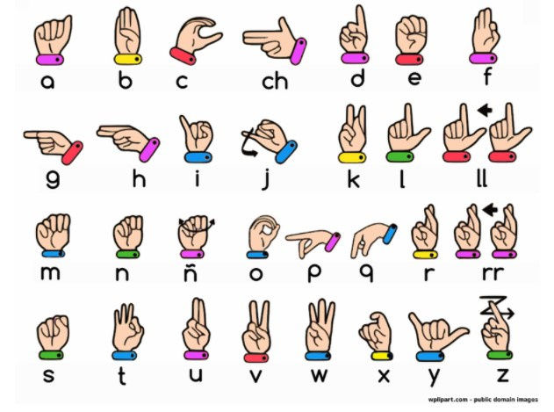

**Backspace**

Fig:1.1

## **1.1 OBJECTIVE:**

More than 70 million deaf people around the world use sign languages to communicate. Sign language allows them to learn, work, access services, and be included in the communities.

To create a computer software and train a model using CNN which takes an image of hand gesture of American Sign Language and shows the output of the particular sign language in text format converts it into audio format.

**Recognize Hand Gestures and Movements**

* Detect and classify static (e.g., alphabets, numbers) and dynamic (e.g., sentences or phrases) gestures in real-time.

**Facilitate Communication**

* Translate ISL into text or speech to enable seamless interaction between ISL users and non-ISL users.
* Make the system user-friendly and adaptable for diverse contexts (e.g., education, healthcare, customer service).

**Increase Accessibility**

* Develop an affordable, portable solution that works on commonly available devices like laptops.

**Improve Accuracy and Robustness**

* Handle variations in hand shapes, sizes, lighting conditions, and backgrounds.

## **1.2 SCOPE:**

This System will be Beneficial for Both Dumb/Deaf People and the People Who do not understands the Sign Language. They just need to do that with sign Language gestures and this system will identify what he/she is trying to say after identification it gives the output in the form of Text as well as Speech format.

* Enables seamless interaction between individuals who use **Indian Sign Language (ISL)** and those who do not understand it.
* Acts as a real-time interpreter, converting sign language gestures into text or speech.
* Helps in **teaching ISL** to individuals who want to learn sign language, including teachers, students, and professionals.

**1.3 Project Modules:**

* Data Acquisition
* Data pre-processing and Feature extraction
* Gesture Classification
* Text and Speech Translation

## **1.4 Project Requirements:**

### **1.1.4 Hardware Requirement**

* Webcam

### **1.2.4 Software Requirement**

* **Operating System:** Windows 8 and Above
* **IDE:** PyCharm
* **Programming Language:** Python 3.9 5
* **Python libraries:** OpenCV,NumPy,Keras,mediapipe,Tensorflow

# **Chapter 2 :Literature Review**

**2.1 )Conversion of Sign Language into Text**

**Mahesh Kumar N B1 Assistant Professor (SeniorGrade),Bannari Amman Institute of Technology, Sathyamangalam, Erode, India (2018):**

This paper shows the sign language recognizing of 26 hand gestures in Indian sign language using MATLAB. The proposed system contains four modules such as: pre-processing and hand segmentation, feature extraction, sign recognition and sign to text. By using image processing the segmentation can be done. Otsu algorithm is used for segmentation purposes Some of the features are extracted such as Eigen values and Eigen vectors which are used in recognition. The Linear Discriminant Analysis (LDA) algorithm was used for gesture recognition and recognized gestures are converted into text and voice format. The proposed system helps to dimensionality.

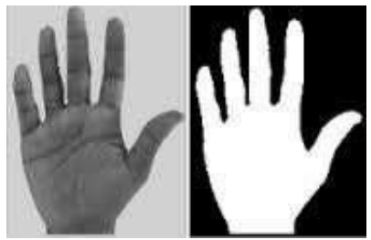 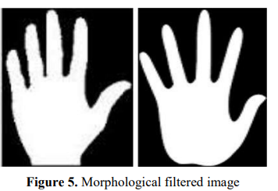

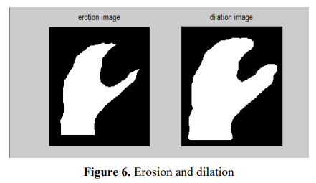 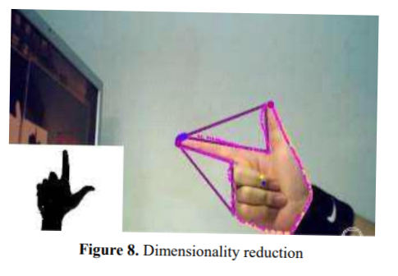

Fig:1

**2.2)Translation of Sign Language Finger-Spelling to Text using Image Processing-by Krishna Modi Mukesh**

In this proposed system, they intend to recognize some very basic elements of sign language and to translate them to text. Firstly, the video shall be captured frame-by-frame, the captured video will be processed and the appropriate image will be extracted, this retrieved image will be further processed using BLOB analysis and will be sent to the statistical database here the captured image shall compared with the one saved in the database and the matched image will be used to determine the performed alphabet sign in the language. Here, they will be implementing only

American Sign Language Finger-spellings, and They will construct words and sentences with them. With the proposed method, they found that the probability of Obtaining desired output is around **93% which** is sufficient and Can be enough to make it suitable to be used on a larger scale For the intended purpose.

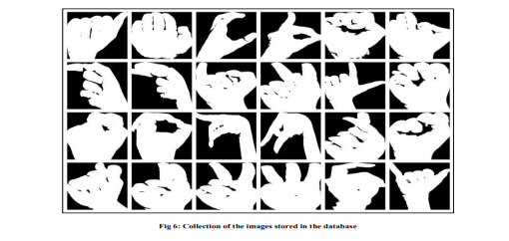

Fig:2

**2.3)An Improved Hand Gesture Recognition Algorithm based onimage contours to Identify the American Sign Language-by Rakesh Kumar(2021)**

This paper proposed a recognition and classification of hand gesture to identify the correct denotation with maximum accurateness for standard American Sign Language. The proposal intelligently used the information based on image contours to identify the character's representation of hand gesture. The proposal optimizes the performance overhead through identifications of 17 characters and 6 symbols based on image contours and convexity measurement of Standard American Sign Language without using complex algorithms and specialized hardware devices. Accuracy measurement done through simulation, which shows how their proposal provides more accuracy with minimum complexity in comparison to other state-of-the-art works. The average accuracy is **86%** overall.

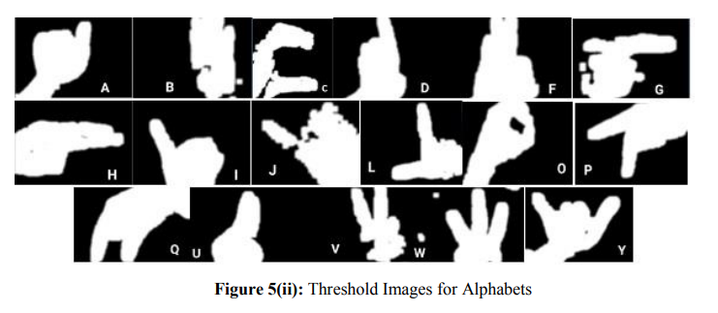

Fig:3

**2.4)Conversion Of Sign Language To Text And Speech Using Machine Learning Techniques**

**Author : Victorial Adebimpe Akano(2018)**

To convert ASL signed hand gestures into text as well as speech using unsupervised feature learning to eliminate communication barrier with the hearing impaired and as well provide teaching aid for sign language.

Sample images of different ASL signs were collected using the Kinect sensor using the image acquisition toolbox on MATLAB. About five hundred (500) data samples (with each sign count five and ten (5-10)) were collected as the training data. The reason for this is to make the algorithm very robust for images of the same database in order to reduce the rate of misclassification. The combination FAST and SURF with a KNN of 10 also showed that unsupervised learning classification could determine the best matched feature from the existing database. In turn, the best match was converted to text as well as speech. The introduced system achieved a **92%** accuracy of supervised feature learning and **78%**of unsupervised feature learning

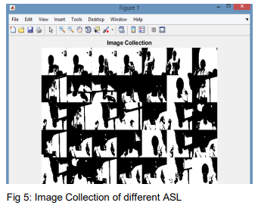 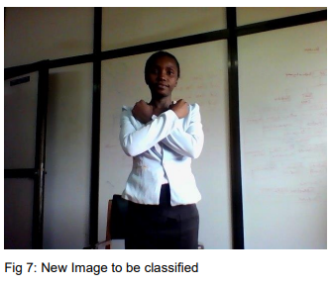

Fig:4

**2.5) Sign Language Interpreter using Image Processing and Machine**

**Learning Author**-**Omkar Vedak1, Prasad Zavre2, Abhijeet Todkar3, Manoj Patil4**

Speech impairment is a disability which affects one’s ability to speak and hear. Such individuals use sign language to communicate with other people. Although it is an effective form of communication, there remains a challenge for people who do not understand sign language to communicate with speech impaired people. The aim of this paper is to develop an application which will translate sign language to English in the form of text and audio, thus aiding communication with sign language. The application acquires image data using the webcam of the computer, then it is pre processed using a combinational algorithm and recognition is done using template matching. The translation in the form of text is then converted to audio. The database used for this system includes 6000 images of English alphabets. We used 4800 images for training and 1200 images for testing. The system produces 88% accuracy.

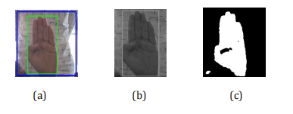

Fig:5

# **Chapter 3 : System Analysis And Design**

## **3.1 Comparison Table**

|  |  |  |  |  |  |
| --- | --- | --- | --- | --- | --- |
| **Author name** | **Mahesh Kumar** | **Krishna Modi** | **Omkar Vedak** | **Victorial Adebimpe Akano** | **Rakesh Kumar** |
| **Algorithm** | **LDA** | **Blob Analysis** | **SVM** | **KNN** | **contour measurement** |
| **Accuracy** | **80%** | **93%** | **80%** | **92%** | **86%** |
| **Year** | **2018** | **2013** | **2019** | **2020** | **2018** |

## **3.2 Project Feasibility Study**

### **3.2.1 Operational feasibility**

### The whole purpose of this system is to handle the work much more accurately and efficiently with less time consumption.

* This app is very user-friendly to use. They only require knowledge about American Sign Language.
* The system is operationally feasible as it is very easy for the End users to operate it. It only needs basic information about windows application.

### **3.2.2 Technical feasibility**

### The technical needs of the system may include:

Front-end and back-end selection An important issue for the development of a project is the selection of suitable front-end and back-end. When I decided to develop the project, I went through an extensive study to determine the most suitable platform that suits the needs of the organization as well as helps in development of the project. The aspects of study included the following factors.

**3.2.1.2 Front-end selection:**

It must have a graphical user interface that assists users that are not from IT background.So we have made front-end using Python Tkinter Gui.

Features:

1. Scalability and extensibility.

2. Flexibility.

3. Easy to debug and maintain.

**3.2.2.2 Back-end Selection:**

I have used Python as Back-end Language which has the most widest library collections The technical feasibility is frequently the most difficult area encountered at this stage. App will fit perfectly for technical feasibility.

### **3.3.3 Economic Feasibility:**

The developing system must be justified by cost and benefit.Since the system is developed as part of project work, there is no manual cost to spend for the proposed system.

**3.3 Detailed Module Description:**

### **3.3.1 Data Acquisition**

The different approaches to acquire data about the hand gesture can be done in the following ways:

It uses electromechanical devices to provide exact hand configuration, and position. Different glove-based approaches can be used to extract information. But it is expensive and not user friendly.

In vision-based methods, the computer webcam is the input device for observing the information of hands and/or fingers. The Vision Based methods require only a camera, thus realizing a natural interaction between humans and computers without the use of any extra devices, thereby reducing costs. The main challenge of vision-based hand detection ranges from coping with the large variability of the human hand’s appearance due to a huge number of hand movements, to different skin-color possibilities as well as to the variations in viewpoints, scales, and speed of the camera capturing the scene.

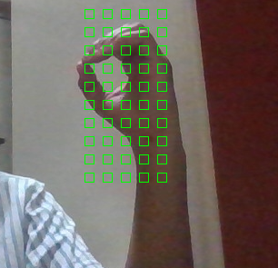

Fig:6

### **3.3.2 Data pre-processing and Feature extraction**

In this approach for hand detection, firstly we detect hand from image that is acquired by webcam and for detecting a hand we used media pipe library which is used for image processing. So, after finding the hand from image we get the region of interest (Roi) then we cropped that image and convert the image to gray image using OpenCV library after we applied the gaussian blur .The filter can be easily applied using open computer vision library also known as OpenCV. Then we converted the gray image to binary image using threshold and Adaptive threshold methods.

We have collected images of different signs of different angles for sign letter A to Z.

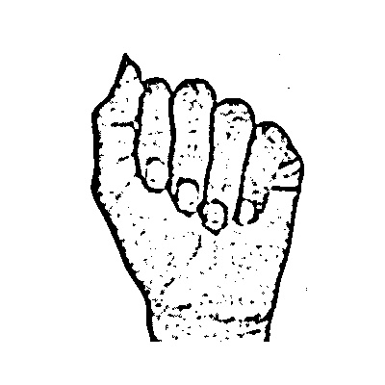

Fig:7

In this method there are many loop holes like your hand must be ahead of clean soft background and that is in proper lightning condition then only this method will give good accurate results but in real world we dont get good background everywhere and we don’t get good lightning conditions too.

So to overcome this situation try different approaches ,firstly detect hand from frame using mediapipe and get the hand landmarks of hand present in that image then we draw and connect those landmarks

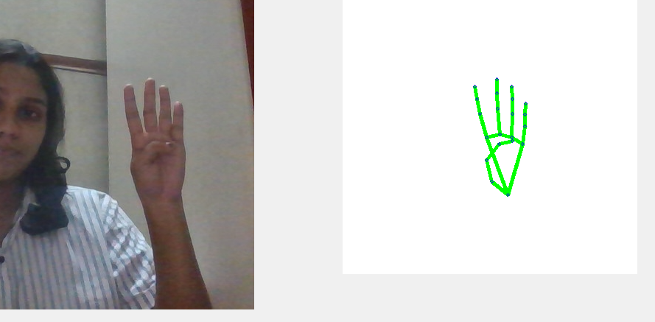

Fig:8

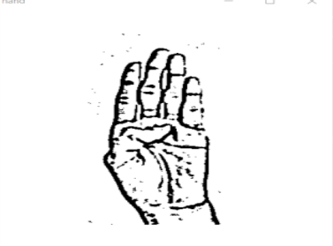

Fig:9

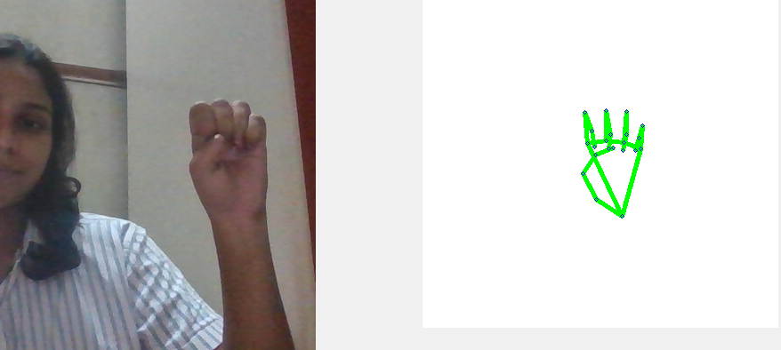

Fig:10

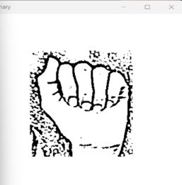

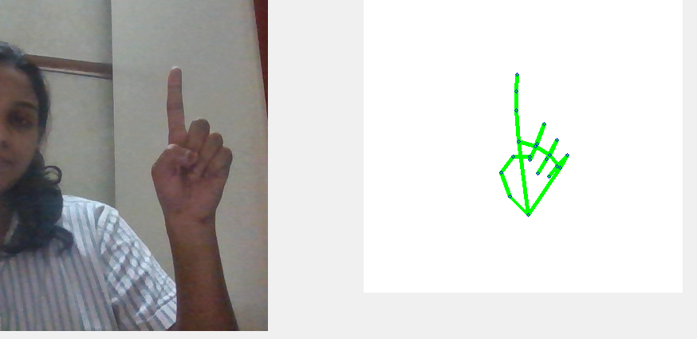

Fig:11

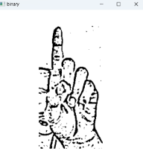

**3.4 Mediapipe Landmark System:**

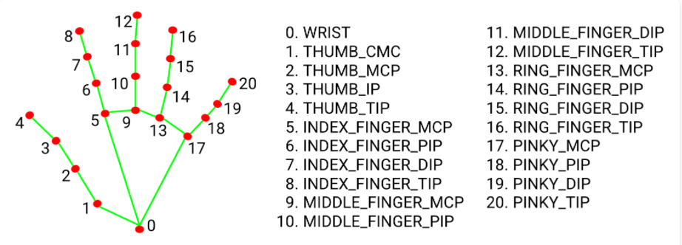

Fig:12

Now we will get this landmark points using opencv library

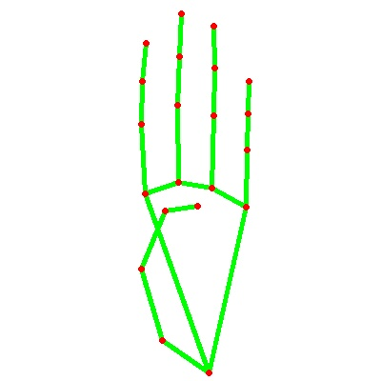 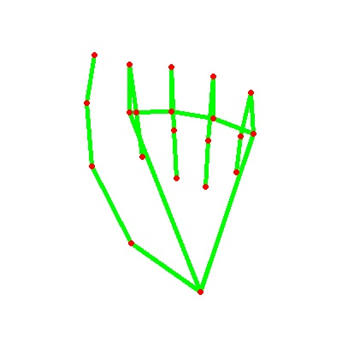

Fig:12.1 Fig:12.2

By doing this we tackle the situation of background and lightning conditions because the mediapipe labrary will give us landmark points in any background and mostly in any lightning conditions.

We have collected **180 skeleton** images of Alphabets from **A to Z**

**3.5 Gesture Classification :**

**3.5.1 Convolutional Neural Network (CNN):**

CNN is a class of neural networks that are highly useful in solving computer vision problems. They found inspiration from the actual perception of vision that takes place in the visual cortex of our brain. They make use of a filter/kernel to scan through the entire pixel values of the image and make computations by setting appropriate weights to enable detection of a specific feature. CNN is equipped with layers like convolution layer, max pooling layer, flatten layer, dense layer, dropout layer and a fully connected neural network layer. These layers together make a very powerful tool that can identify features in an image. The starting layers detect low level features that gradually begin to detect more complex higher-level features

Unlike regular Neural Networks, in the layers of CNN, the neurons are arranged in 3 dimensions: width, height, depth.

The neurons in a layer will only be connected to a small region of the layer (window size) before it, instead of all of the neurons in a fully-connected manner.

Moreover, the final output layer would have dimensions(number of classes), because by the end of the CNN architecture we will reduce the full image into a single vector of class scores.

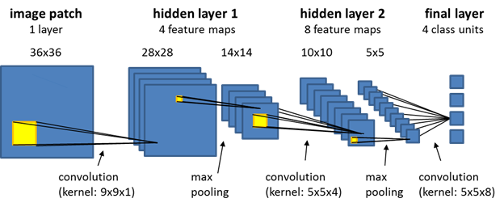

Fig:13

**3.5.1.1 Convolutional Layer:**

In convolution layer I have taken a small window size [typically of length 5*5] that extends to the depth of the input matrix.

The layer consists of learnable filters of window size. During every iteration I slid the window by stride size [typically 1], and compute the dot product of filter entries and input values at a given position.

As I continue this process well create a 2-Dimensional activation matrix that gives the response of that matrix at every spatial position.

That is, the network will learn filters that activate when they see some type of visual feature such as an edge of some orientation or a blotch of some colour.

**3.5.2.1 Pooling Layer:**

We use pooling layer to decrease the size of activation matrix and ultimately reduce the learnable parameters.

There are two types of pooling:

**a. Max Pooling:**

In max pooling we take a window size [for example window of size 2*2], and only taken the maximum of 4 values.

Well lid this window and continue this process, so well finally get an activation matrix half of its original Size.

**b. Average Pooling:**

In average pooling we take average of all Values in a window.

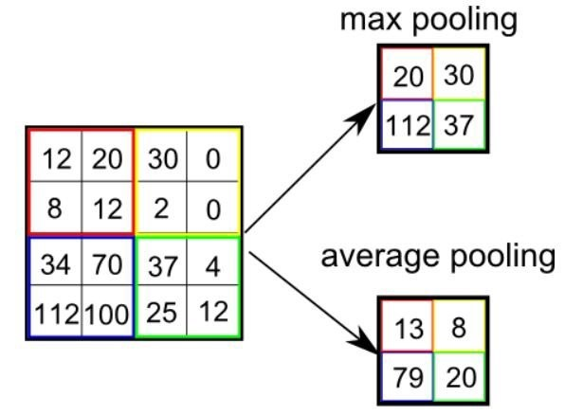

Fig:14

**3.5.3.1 Fully Connected Layer:**

In convolution layer neurons are connected only to a local region, while in a fully connected region, well connect the all the inputs to neurons.

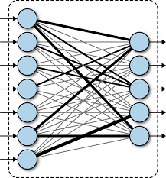

Fig:15

The preprocessed **180 images/alphabet** will feed the keras CNN model.

Here I have divided whole **26 different alphabets into 8 classes** in which every class contains similar alphabets:

* **For Y and J**

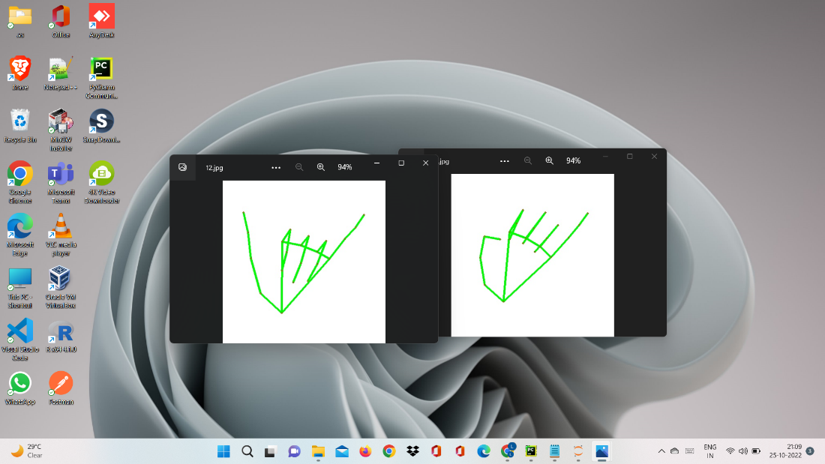

Fig:16

* **For C and O**

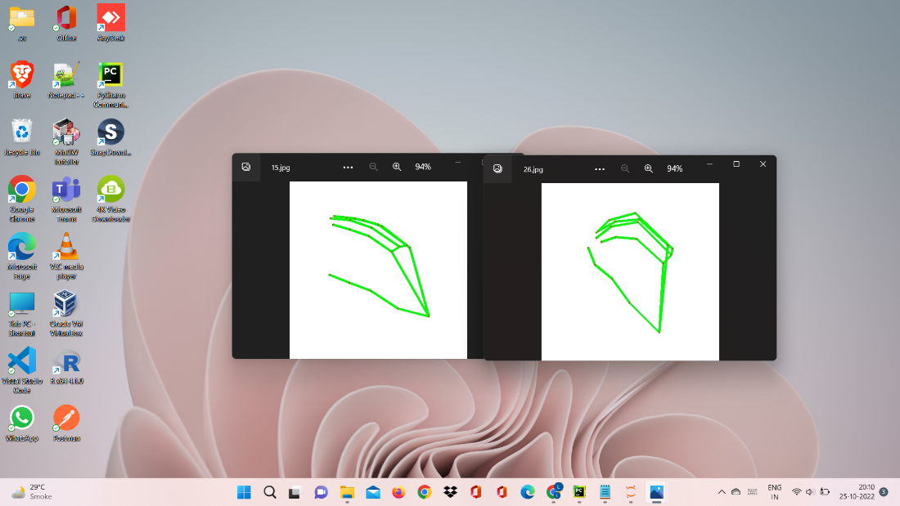

Fig:17

* **For G and H**

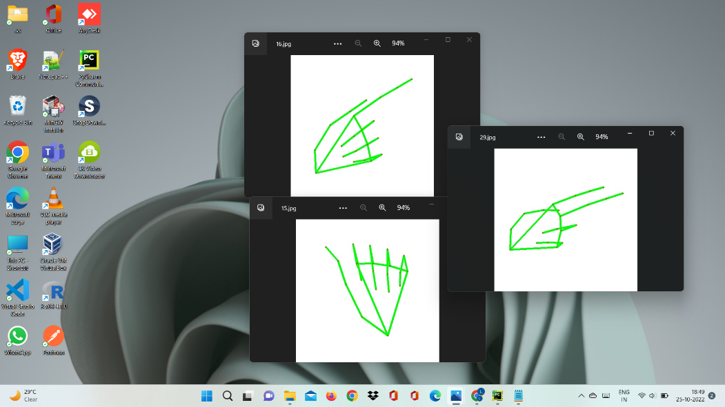

Fig:18

* **For B,D,F,I,U,V,K,R and W**

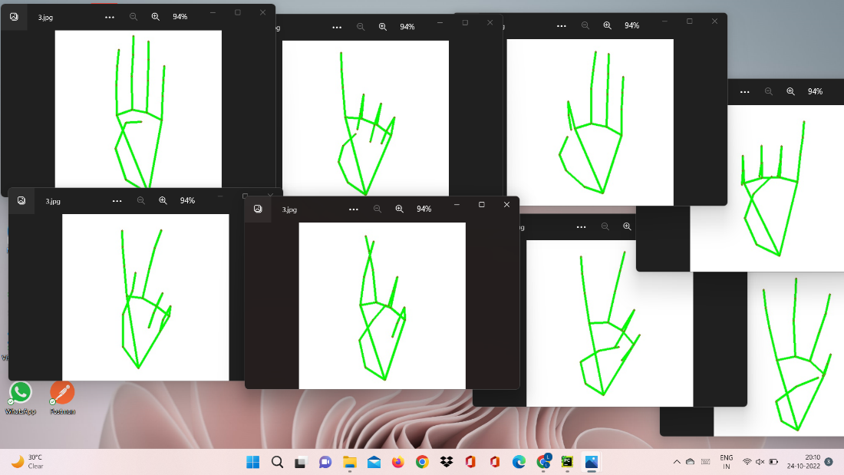

Fig:19

* **For P ,Q and Z**

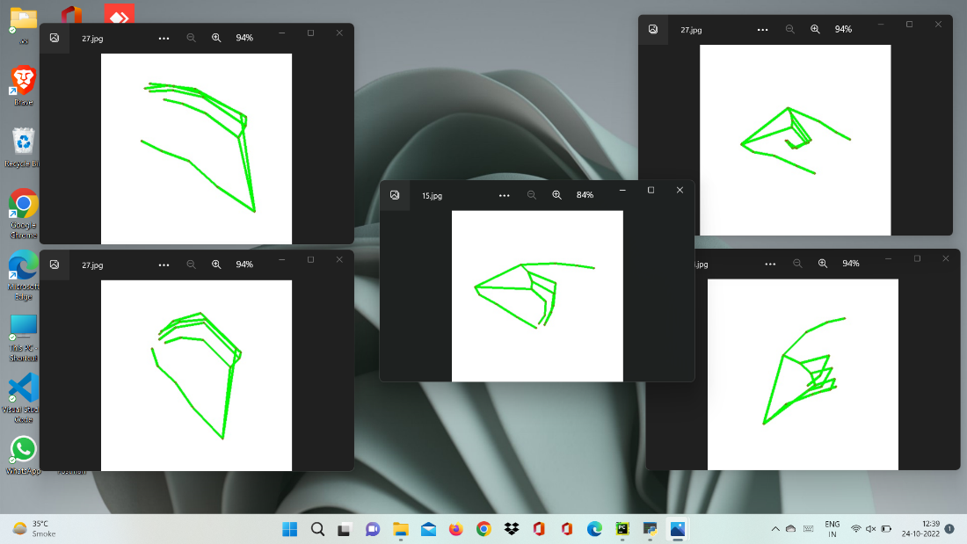

Fig:20

* **For A, E,M ,N ,S and T**

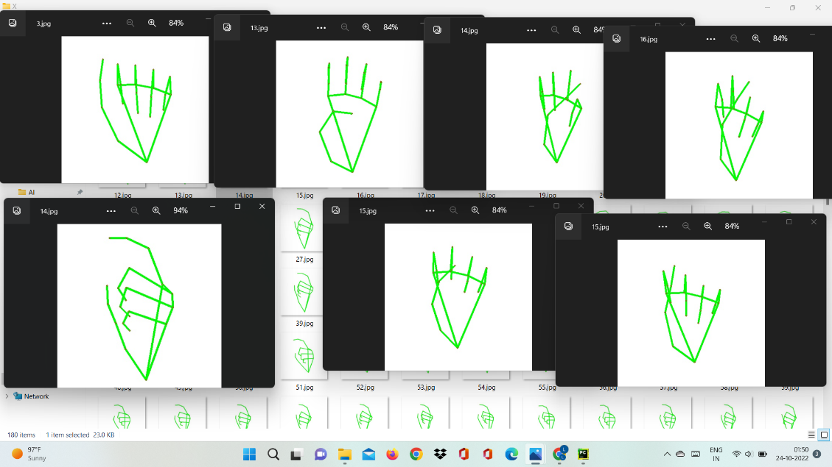

Fig:21

### **3.6 Text and Speech Translation**

### The model translates known gestures into words. we have used pyttsx3 library to convert the recognized words into the appropriate speech. The text-to-speech output is a simple workaround, but it's a useful feature because it simulates a real-life dialogue.

**3.7 Language Translation:**

**Tkinter GUI**: Creates a user-friendly interface with text areas and dropdowns.

**Google Translate API:** Uses googletrans to perform translations.

In this the converted text/sentence will get translated into desired language according to the user comfort.If any user is not able to get the english texts he/she can translate the english output in his comfort language get what exactly the word or sentece is.

**3.8 PLANNING AND SCHEDULING:**

**3.8.1 Gantt Chart:**

A Gantt chart, commonly used in project management, is one of the most popular and useful ways of showing activities (tasks or events) displayed against time. On the left of the chart is a list of the activities and along the top is a suitable time scale. Each activity is represented by a bar the position and length of the bar reflect the start date, duration and end date of the activity

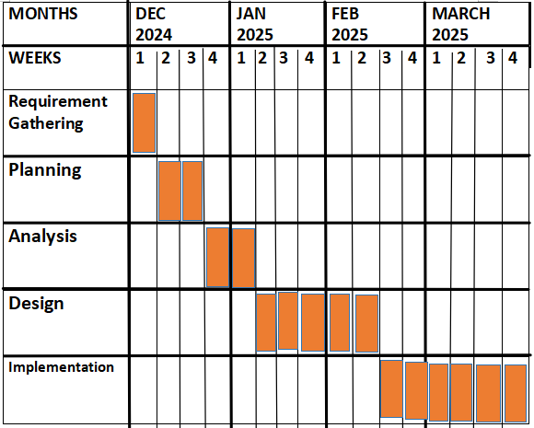

Fig:22

**3.8.2 System Flowchart:**

A system flowchart is a visual representation of how your sign language prediction system processes input (video/sign gestures) and produces output (translated text/speech).

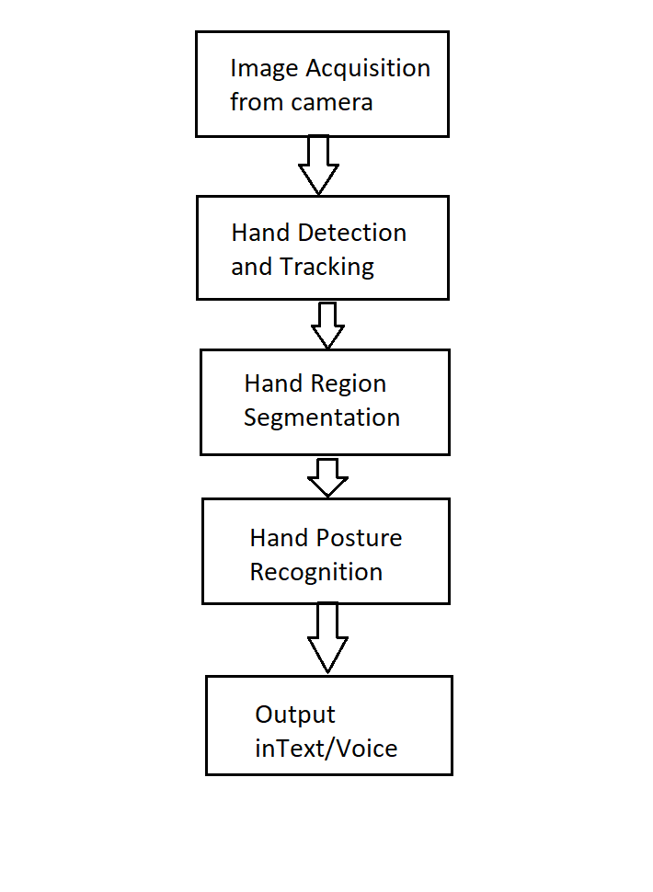

Fig:23

**3.8.3 Use-case diagram**

A **Use Case Diagram** is a **visual representation** of how users (actors) interact with a system. It shows:

**Actors (users or external systems)**

**Use Cases (actions they can perform)**

**Relationships (how actors interact with use cases)**

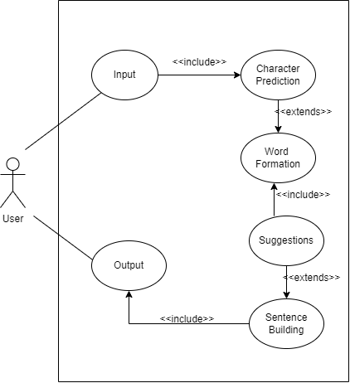

Translation(if user face issue with english language)

Fig:24

**3.8.4 DFD Diagram**

A **Data Flow Diagram (DFD)** visually represents how data moves through a system, showing:

**Processes (actions that transform data)**

**Data Stores (where data is stored temporarily or permanently)**

**External Entities (users or other systems interacting with the system)**

**Data Flows (how data moves between components)**

* **Levels of DFD**

**Level 0 (Context Diagram)** → Shows the entire system as a single process interacting with external entities.

**Level 1 DFD** → Breaks down the main process into subprocesses.

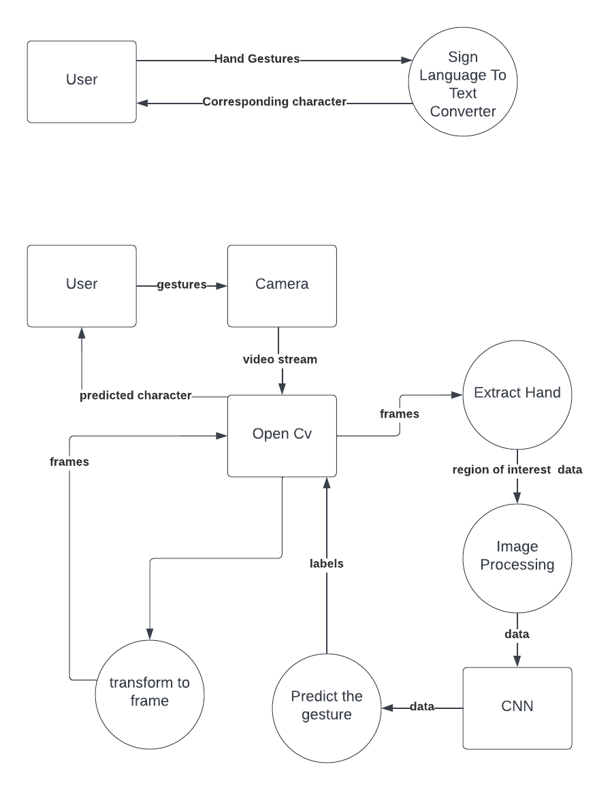

Fig:25

**3.8.1.4 DFD-Level 1:**



Translation

Fig:26

**Chapter-4: Implementation and Testing**

Here are some snapshots when user shows some hand gestures in different background as well as in different lightning conditions and system is giving corresponding prediction.

**4.1 Speak Button:**

If you want to convert translated text into speech, you can use Text-to-Speech (TTS) with a "Speak" button.

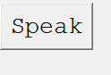

**4.2 Clear Button:**

A "Clear" button will erase the text from the output box, allowing users to enter or translate new text easily.

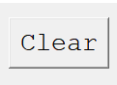

**4.3 Next:**

To type next word use this action

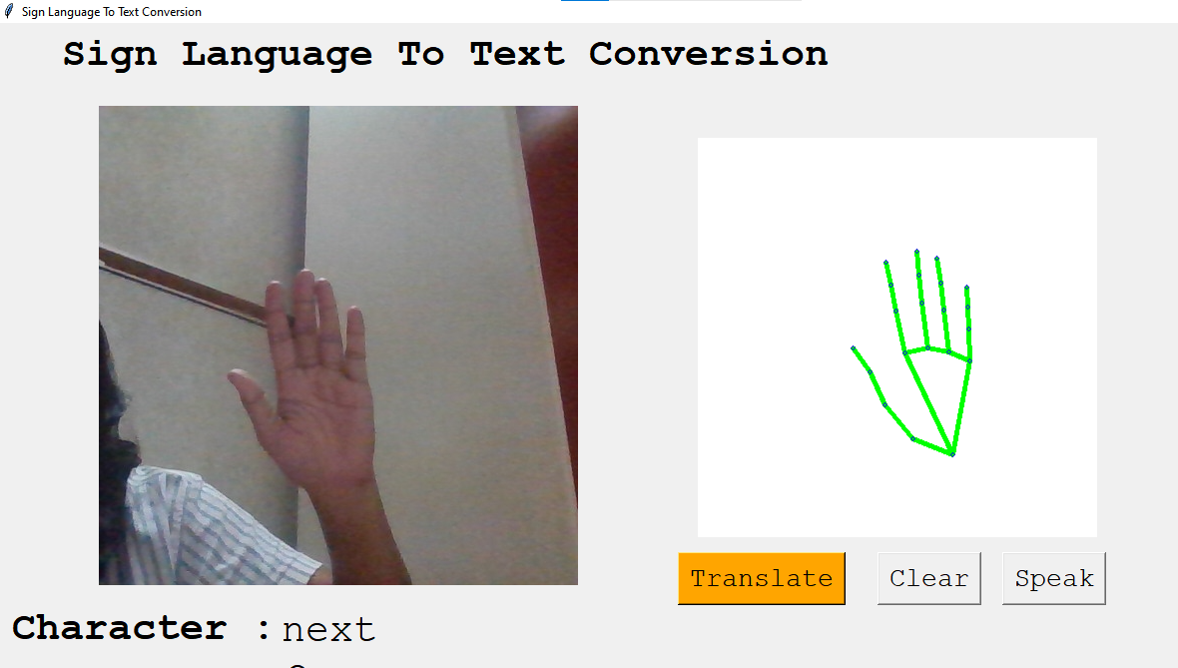

Fig:27

**4.4 Backspace:**

To erase the word use this action.

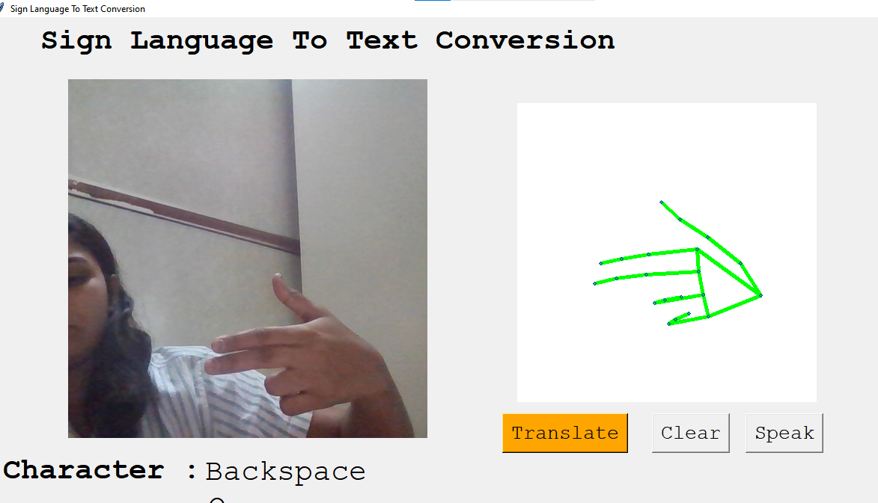

Fig:28

**4.5 Space:**

To give space between two words use this.

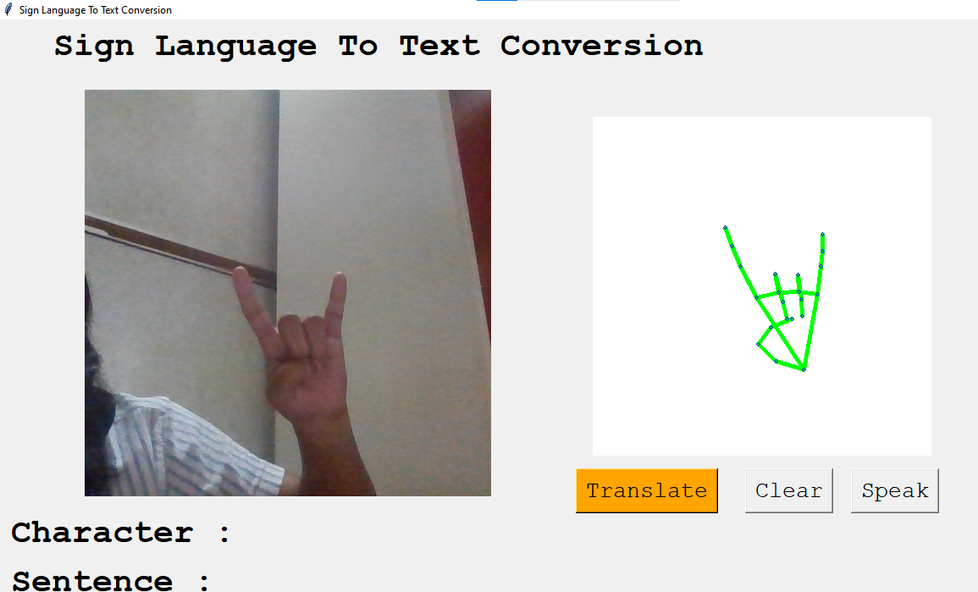

Fig:29

**4.6 Translation Button:**

**"Translate" button** will take the detected sign language input, process it, and display the translated text.

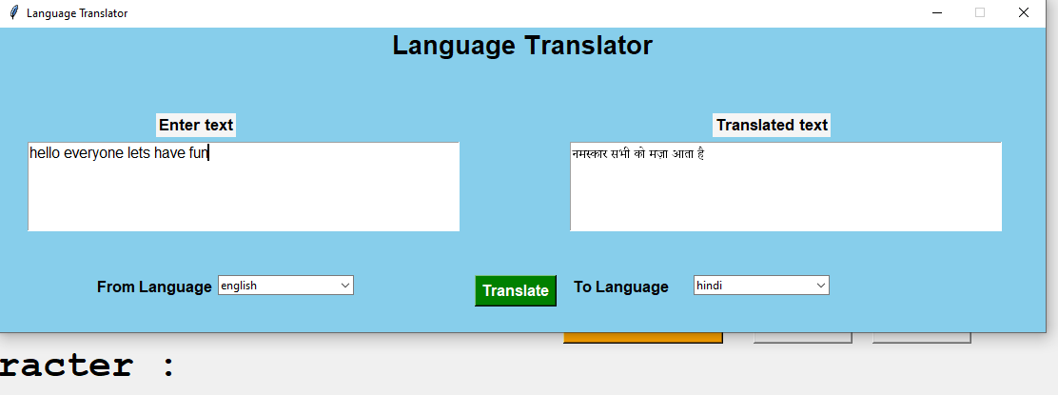

Fig:30

For eg-We want to say’ **HELLO DEAR**’

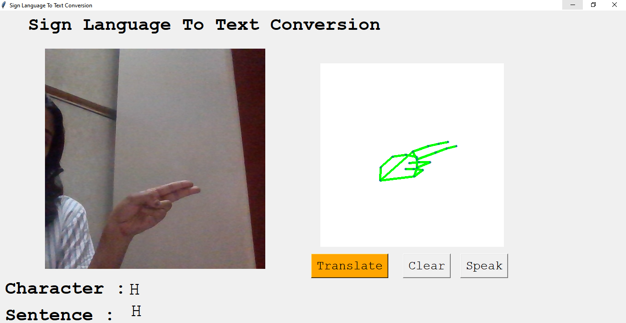

Predicted letter H (Fig:40)

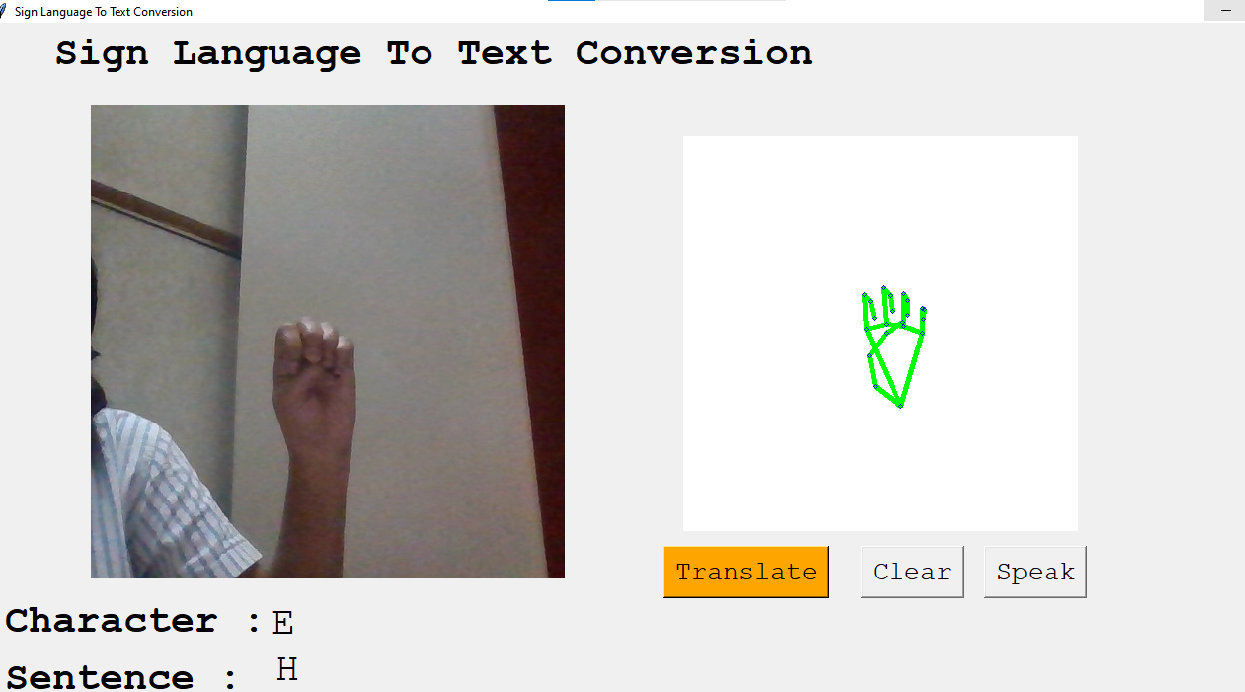

Predicted letter E(Fig:41)

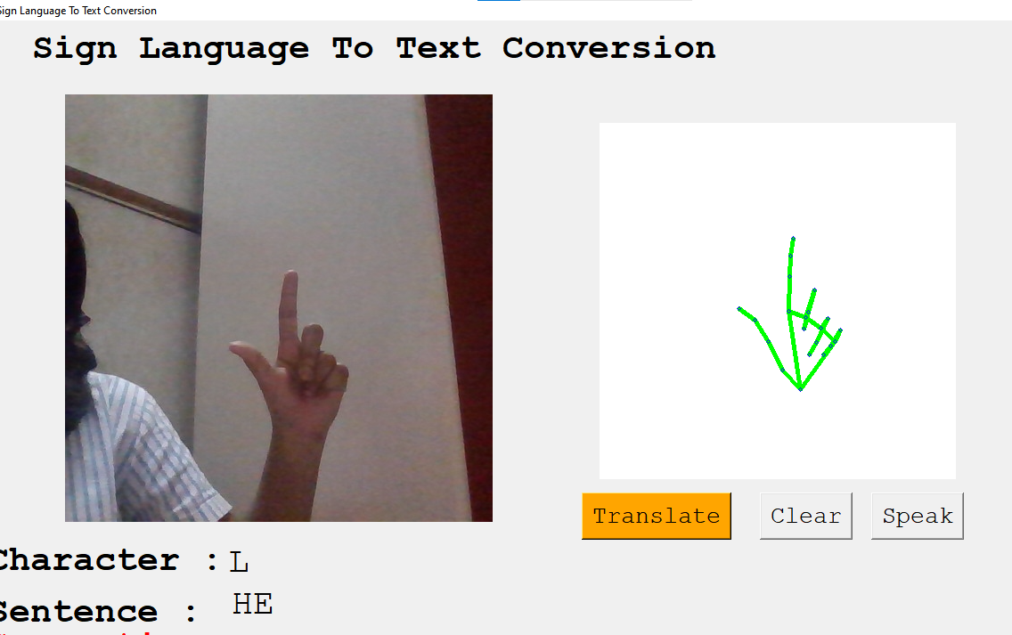

Predicted letter L (Fig:42)

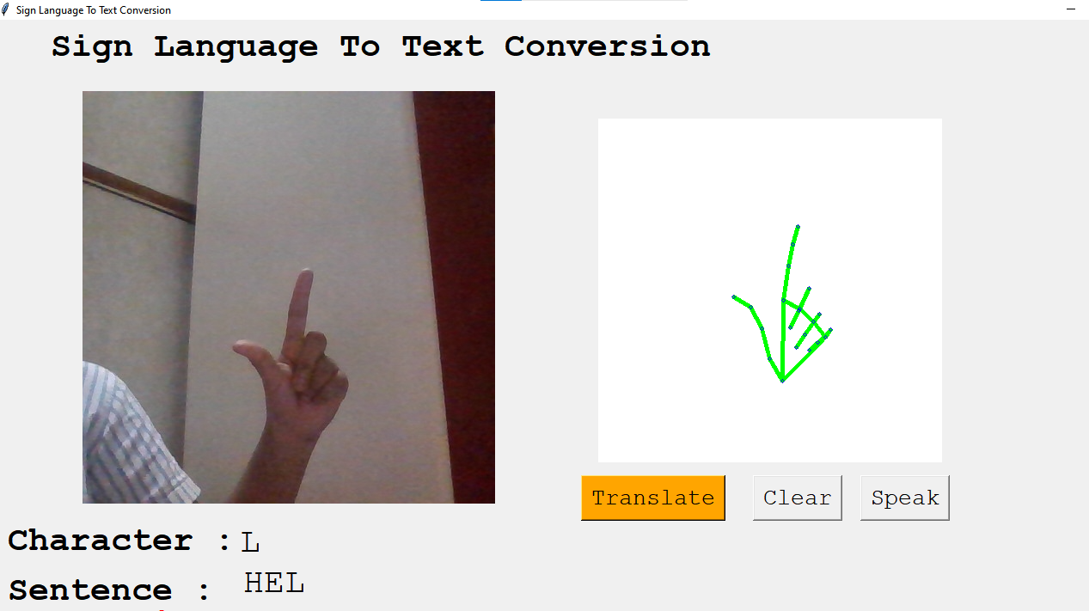

Again Predicted as L (Fig:43)

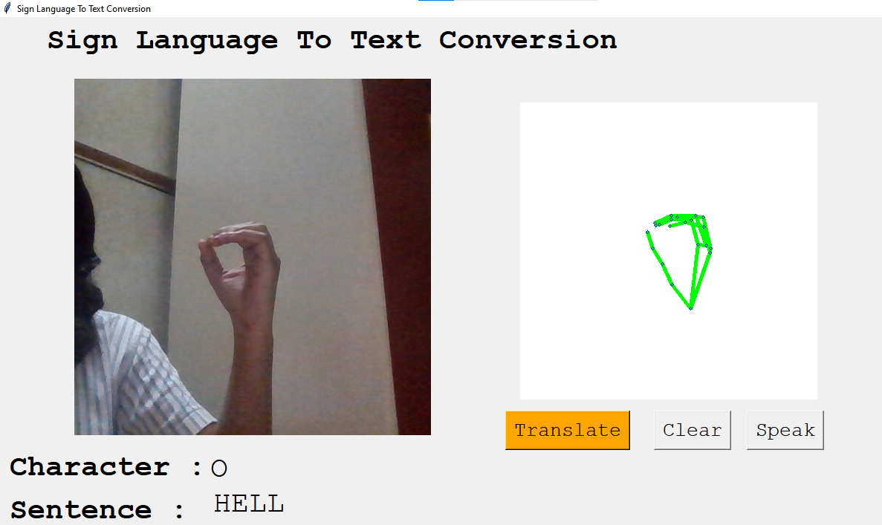

Predicted Letter O (Fig:44)

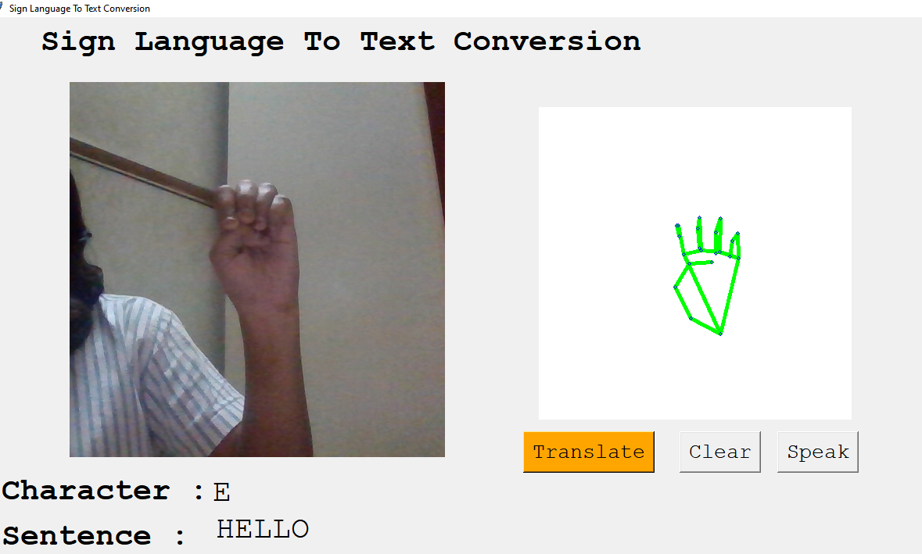

**Hello** word gets typed in sentence (Fig:45)

For ‘Dear’

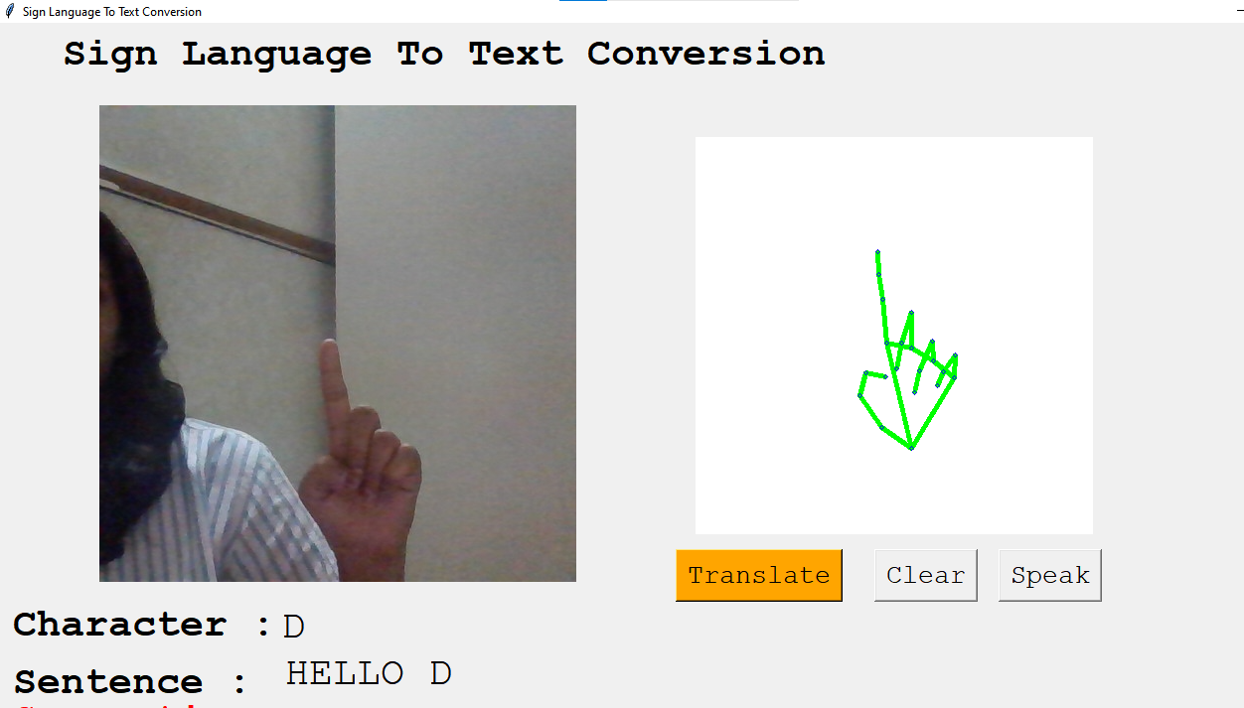

Predicted D letter (Fig:46)

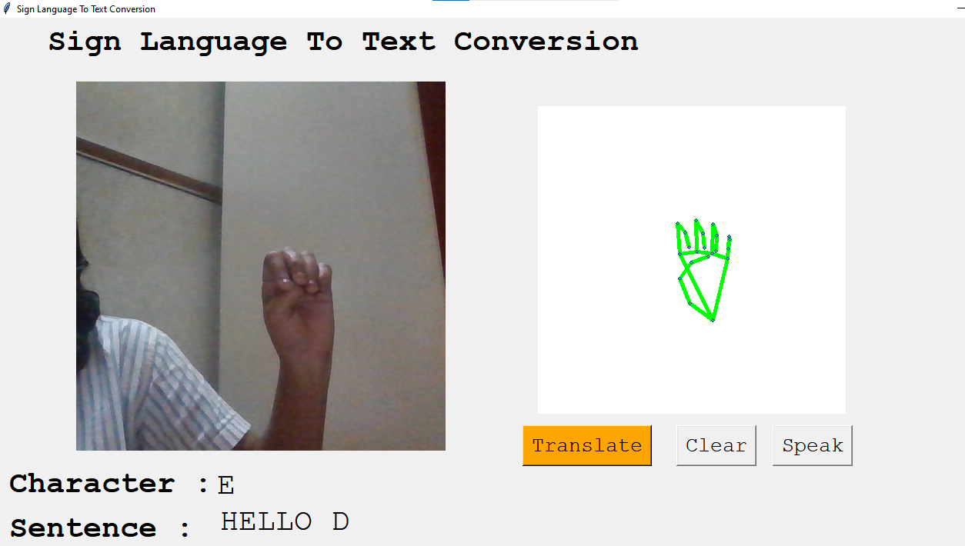

Predicted E letter (Fig:47)

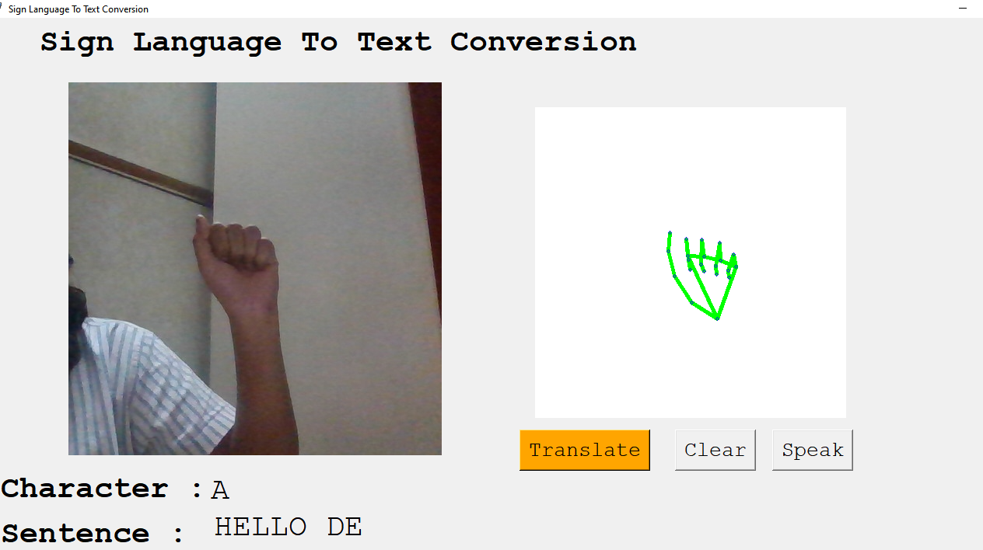

Predicted A letter( Fig:48)

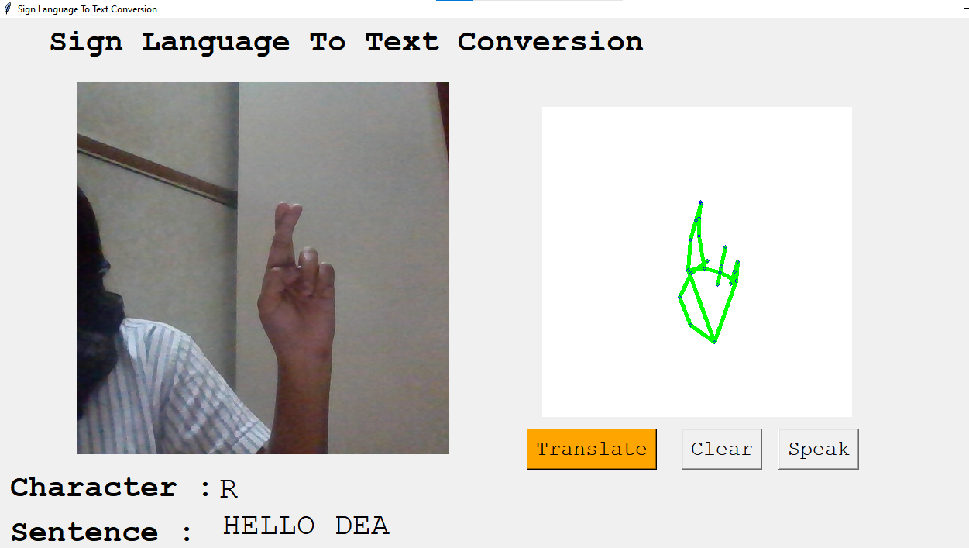

Predicted A letter (Fig:49)

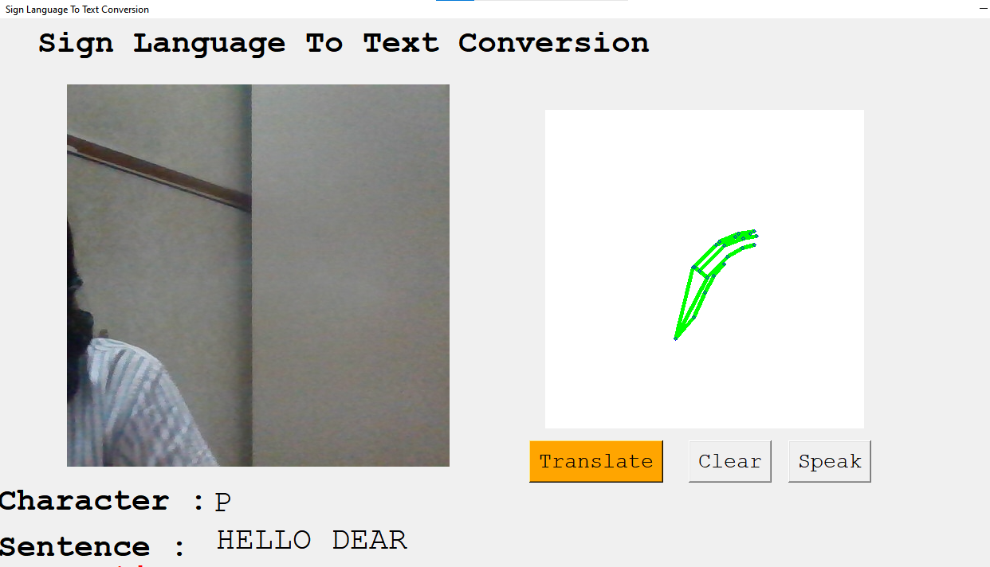

This Form our sentence as **HELLO DEAR(** Fig:50)

If user is facing issue to understand the english language he can go with the desired language which he knows (eg:Hindi or Marathi)

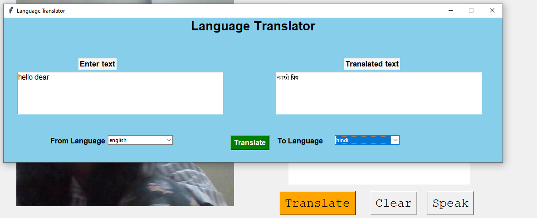

Fig:51

This is the translation tkinter which helps us to translate the sentence in desired language so user don’t need to go back to search anywhere or ask someone , simple type the sentence and hit on translate button

**4.7 CODE:**

**4.7.1 Application Code:**

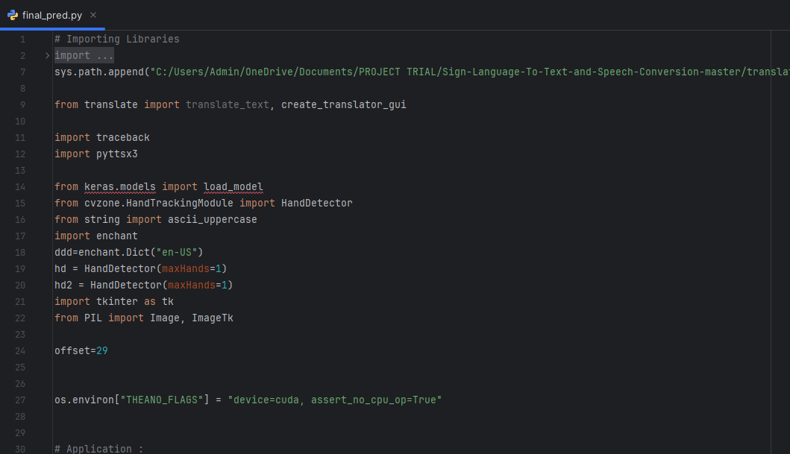

Fig:52

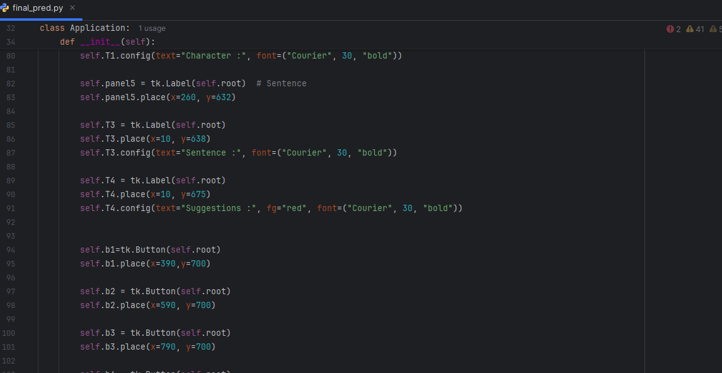

Fig:53

**4.7.2 Translation Code:**

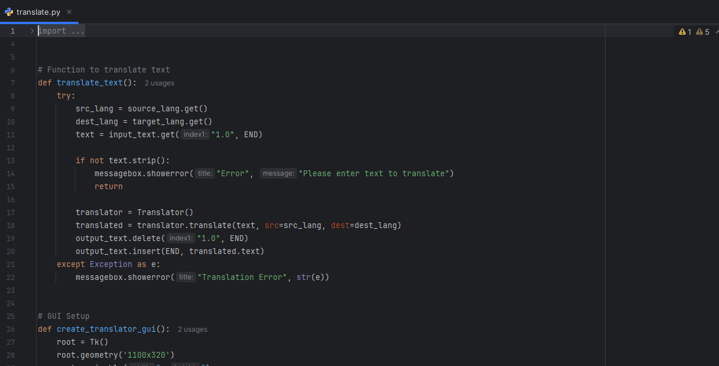

Fig:54

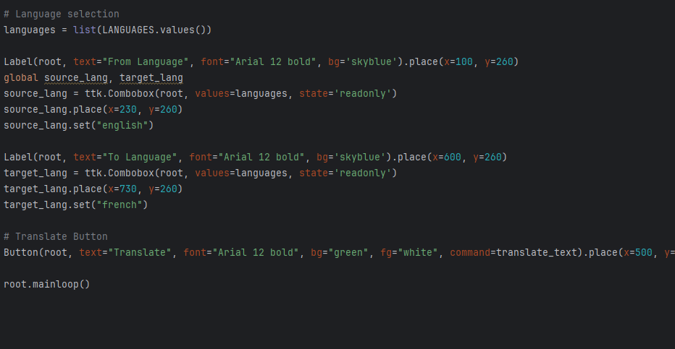

Fig:55

**CHAPTER 5**

**5.1 Conclusion:**

Indian Sign Language (ISL) prediction using machine learning (ML) has shown significant potential for enabling better communication between deaf and hearing-impaired individuals and the general population.Finally, we are able to predict any alphabet[a-z] with **95%** Accuracy (with and without clean background and proper lightning conditions) through our method. And if the background is clear and there is good lightning condition then we got even **95%** accurate results.

**5.2 Future Scope:**

* Develop an AI model that can translate between different sign languages.
* Convert sign gestures into **real-time animated avatars** for better accessibility in video calls, educational content, and entertainment.
* Integrate **emotion recognition** to capture expressions and emotions in sign language for more accurate communication.
* Combine **lip-reading models with sign recognition** for more accurate speech-to-text systems for the hearing impaired.
* Develop AI assistants like **Alexa or Google Assistant** that can understand and respond to sign language.

**REFERENCE:**

1. **Sign language Recognition Using Machine Learning Algorithm** Prof. Radha S. Shirbhate1, Mr. Vedant D. Shinde2, Ms. Sanam A. Metkari3, Ms. Pooja U. Borkar4, Ms. Mayuri A. Khandge5.
2. **Real-time Vernacular Sign Language Recognition using MediaPipe and Machine Learning** Arpita Haldera , Akshit Tayade.
3. **Classification of Sign Language Gestures using Machine Learning** Abhiruchi Bhattacharya1 , Vidya Zope2 , Kasturi Kumbhar3 , Padmaja Borwankar4 , Ariscia Mendes5.
4. **Voice Based Sign Language Detection For Dumb People Communication Using Machine Learning** Akhilesh Pandey1 , Abhilasha Chauhan2 , Ashish Gupta3 , Vijay karnatak.
5. **Sign Language Training Tool Using Machine Learning** Techniques Mahalakshmi V, Asst. Prof. Dr. E. Ranjith
6. **SIGN LANGUAGE RECOGNITION USING MACHINE LEARNING** S.Saravana Kumar1 , Vedant L. Iyangar
7. **SIGN LANGUAGE DETECTION USING MACHINE LEARNING** Bhanu Prakash Vasina1 , Umar Janu Shaik2 , Sukesh Reddy Vinnamala3 , Sadhik Basha Shaik4 Mastanbi Shaik5
8. **Indian Sign Language recognition system using SURF with SVM and CNN** Shagun Katoch a , Varsha Singh b,* , Uma Shanker Tiwary

* **DATASET:**

https://github.com/Devansh-47/tree/master/AtoZ_3.1